

# NACIONAL UNIVERSITY OF LOJA

subject:

**English**

Name:

# Dennys Alexander Pucha Carrera

Loja-Ecuador

2023

DATE: 27-07-2023 GROUP: #3 NAMES: TIMOTEO, TORRES, PUCHA

Sentences:

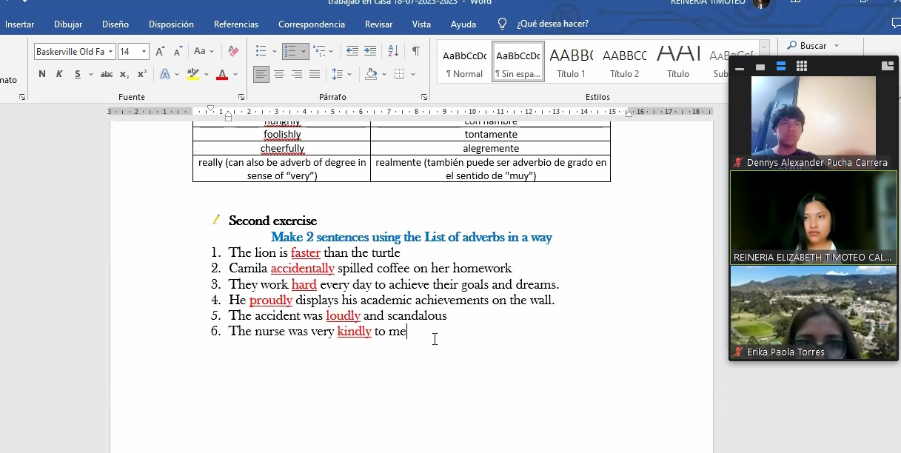

Adverbs:

|  |  |
| --- | --- |
| **Inglés** | **Español** |
| well | bien |
| fast | rápido |
| straight | recto |
| hard | duro |
| loudly | en voz alta |
| proudly | con orgullo |
| suspiciously | sospechosamente |
| strangely | extrañamente |
| kindly | amablemente |
| easily | fácilmente |
| rudely | groseramente |
| neatly | ordenadamente |
| quickly | rápidamente |
| generously | generosamente |
| eagerly | ansiosamente |
| accidentally | accidentalmente |
| rapidly | rápidamente |
| hungrily | hambrientamente |
| foolishly | tontamente |
| cheerfully | alegremente |
| really | realmente |